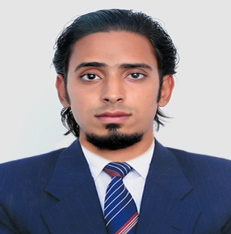



NITISH BHARDWAJ

Mob: -+91 9895220358

E-mail : nitishb3110@gmail.com

**Career Objective:**

Seeking a challenging career as **HR Manager/ Marketing Manager** to make use of my extensive knowledge and skills and synergize with the organization to focus on, and achieve, the long term goals that have been put into place.

**Profile:**

* Completed **MBA International Business** at **School Of Management Studies**, **Cochin University of Science and Technology**,**2013-2015**
* Interested Areas are **HR &** **Marketing.**
* **Good Team player** with communication skills, writing skills and leadership Qualities. Willingness to learn new things and ready to update myself with new methodologies.
* **Confident** and ready to take all responsibilities.

**Education:**

* Completed **Masters of Business Administration (International business)** at “**School of Management studies”, Cochin University of Science and Technology (CUSAT), Cochin, Kerala**, **2013-2015.**
* **BBM** passed from **Chinmaya Vidyapeet, Ernakulam**, under **MG.University 2009-2012.**

**Professional Experience:**

* **1 year** experience as **HR EXECUTIVE** at **BLR Logistics pvt Ltd**, Goregaon, **Mumbai**.
* **6 months** part time experience as **HR EXECUTIVE at Search Management Pvt Ltd,** Cochin.
* **Intern** at **State Bank Of India (Area- Marketing), Cochin** during June-July, 2014

**Special Projects and Activities:**

* **Treasurer of Go Green’14**, A Socio-Management initiative by School of Management Studies, Cochin University of Science and Technology.
* **Cultural Leader** of **Talentime’14**, Management Fest by School of Management Studies.
* **Hospitality & Event Volunteer** of **Talentime’13**, Management Fest hosted by School of Management Studies, Cochin University of Science and Technology.
* Won **1st prize** continuously for **5 years** in **Dance**.
* **School leader & Captain** of Cricket & Football for **2 continuous years**.
* Won **3rd prize** for Chess, Carroms, Badminton & Volleyball.

**Technical Skills:**

* Good working skill in M.S .Office, Visual Basic, Tally, Oracle, Web designing, etc.

**Personal Profile:**

* **Date of Birth** : 31-10-1992
* **languages known** : english, hindi, Malayalam, Gujarati & MARWADI.
* **permanent address** : 8/2357, gUJARATI ROAD, MATTANCHERRY, COCHIN-682002.
* **Hobbies**  : DANCING, PHOTOGRAPHY & TRAVELLING.